**Openmind: Online Education Platform**

**by**

**Vaishnavi Choukwale  
Abhilash Gorle**

**Abhinav Gupta**

**Table of Contents**

Overview 3

I Project Description 4

1 Project Overview 4

2 The Purpose of the Project 4

3 The Scope of the Work 4

II Product Scenarios 4

1 Product Requirement…………………………………..………………………………..4

a. Stakeholders…………..………………………………………………………………6

b. Product Use Cases: 6

2 Architecture Diagram...………………………………………………………………....5

3 Class Diagram…………………………………………………………………………..6

III Functional Requirements 5

IV Data Requirements 6

V System Design 6

1. Software Architecture: 6

2. User Interface: 6

3. Object Design: 6

Overview

This project introduces a visionary concept in the world of education. By shifting the focus from institutions to educators and students, it attempts to address some of the major challenges present in traditional education systems. It is poised to revolutionize education in multiple ways, particularly in terms of accessibility, affordability, and quality.

The potential impact of this digital educational platform is profound:

**Accessibility**: Students worldwide can access courses from any location, eliminating geographical limitations.

**Affordability**: The platform offers courses for free, and payment is only required for certification, reducing financial barriers for students.

**Quality**: The reputation index for professors ensures that students receive high-quality education.

The inclusion of employers in the system, the verification of degrees by third-party certification authorities, and the ability for users to contribute through donations further enhance the platform's credibility, educational quality, and sustainability.

In conclusion, digital educational platforms like this one have the potential to democratize education by making it accessible, affordable, and high-quality for individuals who may not have had these opportunities in the past. By empowering both educators and learners and by welcoming the support of contributors, this platform represents a significant step forward in the world of education.

# Project Description

## Project Overview

This project aims to develop a decentralized educational platform, inspired by Coursera, where education is liberated from the confines of traditional institutions. Professors are at the heart of the students' learning experience, and the system seeks to provide quality education while making it accessible and affordable to learners worldwide.

## The Purpose of the Project

The primary purpose of this project is to create an innovative educational platform that shifts the focus from educational institutions to professors. Professors are given complete autonomy to design and offer courses, while students have the flexibility to choose courses that best suit their learning needs. The project intends to democratize education, reduce tuition costs, and improve the quality of learning for students globally.

## The Scope of the Work

The scope of the project encompasses the creation of a fully functional decentralized educational platform. This platform will provide features such as professor and student registration, course management, course registration, graduation assessment, and mechanisms for feedback. It also encourages contributions from individuals who wish to support this noble cause through donations.

# Product Scenarios

**1. Product Requirements:**

**a. Stakeholders**

1. Professors: Educators who create and manage courses.

2. Students: Enroll in courses and work towards earning degrees.

3. Employers: Access student data and provide feedback.

4. Platform Owners: Oversee platform operation and data analytics.

5. Third-Party Certification Authorities: Approve degrees for graduation.

**b. Product Use Cases:**

**Use Case:** Registration

**Primary Actor:** Professor/Student/Employer

**Main Flow:**

1. Users access the system's registration page.

2. Users provide the necessary information (name, contact details, academic qualifications, etc.).

3. The system verifies and authenticates the provided information.

**Use Case:** Course Management and Feedback

**Primary Actor:** Professor

**Main Flow:**

1. The system displays options to add courses to their catalog for the upcoming term(s).

2. The professor adds one or two courses to their catalog, including course title, description, and schedule.

3. The professor can update the courses anytime to add more lectures and project requirements.

4. Professors can view their student's performance through grades and project completion.

5. The professor can view the feedback, which is filtered and sent by the admin to avoid any negativity spreading on the platform.

**Use Case: Student Course Registration**

**Primary Actor: Student**

**Main Flow:**

1. After successful registration, the student logs in and views their dashboard.

2. They can visit the registration section to browse courses and filter them based on the region, year uploaded, language, semester, and professor. The system displays a list of available courses and relevant details (title, professor, schedule, rating).

3. The student selects the courses they wish to register for.

**Use Case:** Student Course Completion

**Primary Actor:** Student

**Main Flow:**

1. The system processes the registration, updating the student's schedule and transcript.

2. They can view the lectures and project requirements once registered.

3. They can mark project requirements complete to initiate the graduation process.

4. Based on the requirements completed, the students are graded.

**Use Case:** Graduation Declaration

**Primary Actor:** Student

**Main Flow:**

1. The student navigates to the "Graduation Declaration" section.

2. The system reviews the student's transcript and verifies if they have taken a maximum of 8 courses for an MS degree.

3. If the criteria are met, the system confirms that the student is eligible for graduation.

4. Only the top 8 scoring subjects are considered to generate their transcript.

**Use Case:** Transcript Review

**Primary Actor:** Platform Administrator

**Main Flow:**

1. The Admin first reviews the transcript and then forwards it to a third-party authorization company that helps improve the credibility of the degree.

2. If the student still needs to meet the graduation requirements, the system provides a message indicating the remaining actions needed for eligibility.

3. Students are also able to add skills that are shown to potential employers to facilitate job search and internships.

**Use Case:** Platform Performance Data Collection

**Primary Actor:** Platform Administrator

**Main Flow:**

1. The administrator accesses the "Performance Data" dashboard.

2. The system displays various metrics and analytics related to platform usage, user engagement, course popularity, student performance, etc.

**Use Case:** Manage Users

**Primary Actor:** Platform Administrator

**Main Flow:**

1. The administrator accesses all user data and holds the authority to add, update, and delete operations.

2. They can view all information about course schedules, professor courses, students registered, and their performances individually

**Use Case:** Donations

**Primary Actor:** All Users

**Main Flow:**

1. Any Individual who wishes to associate with the platform can support it by providing donations.

2. Users receive feedback through pictures about how their donation money is being spent.

2**. Architecture Diagram:**

*Click on link below*



**3. Class Diagram:**

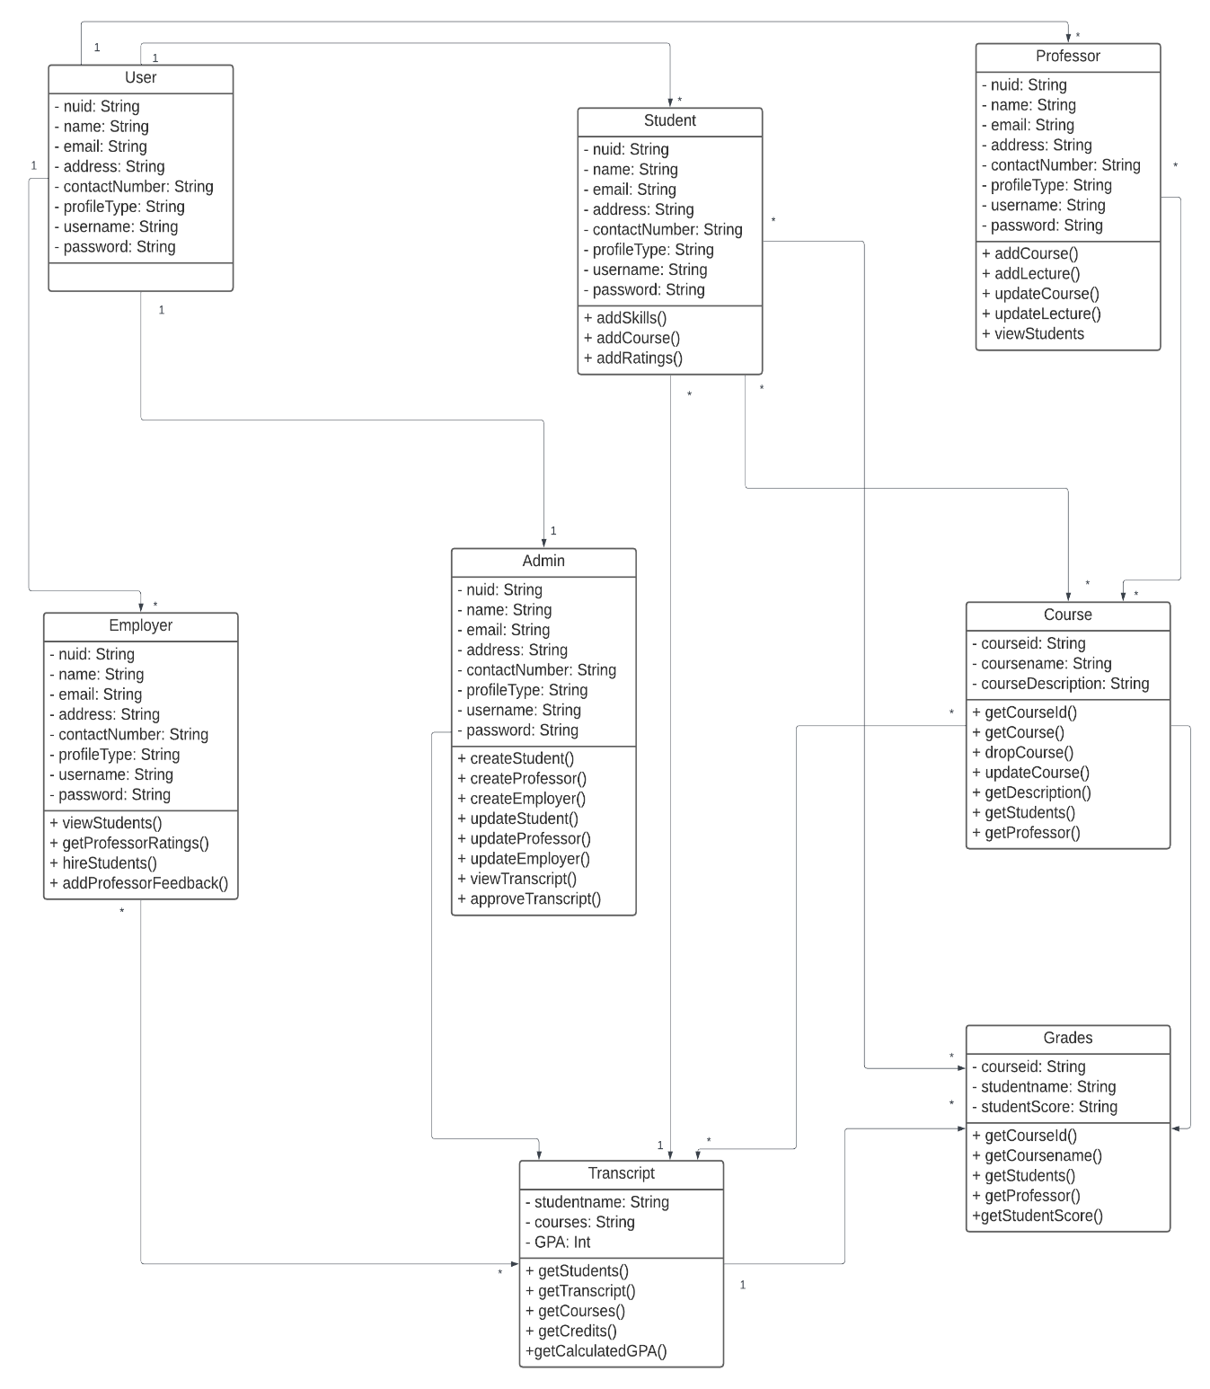

# Functional Requirements

1. User Registration and Authentication System: Develop a robust registration and authentication system for professors and students.

2. Course Creation and Management: Enable professors to create, schedule, and manage courses on the platform.

3. Course Search and Registration: Students should be able to search for courses and register for those of their choice.

4. Graduation Assessment: Implement an automated assessment system to determine a student's readiness to graduate.

5. Employer Access and Feedback: Provide a mechanism for employers to access student data and submit feedback.

6. Data Analytics Dashboard: Create a dashboard to allow platform owners to analyze data.

7. Donation Feature: Implement a feature that allows individuals to contribute to the platform's sustainability.

# Data Requirements

1. **Student and Professor Profiles**: Maintain comprehensive profiles of both students and professors.

2. **Course Details and Ratings**: Keep records of course details and professor ratings to assist students in their choices.

3. **Transcripts and Degree Status**: Store student transcripts and degree status information.

4. **Employer Feedback Data**: Manage data related to employer feedback on students' performance.

# System Design

### 1. Software Architecture:

The software architecture is founded on the decentralized model, with a focus on role management using the Java package. The role management system is crucial for the proper functioning of the platform, ensuring professors and students have distinct roles with associated privileges.

### 2. User Interface:

The user interface is designed to be intuitive and user-friendly, providing easy access to registration, course search, transcript viewing, feedback submission, and the donation feature. The design is aimed at enhancing the user experience and overall satisfaction.

### 3. Object Design:

The object design is structured around key classes such as professors, students, courses, transcripts, and employers. Each class is equipped with methods and attributes essential for the platform's smooth operation, making it possible for users to carry out their tasks efficiently.

# Conclusion

We firmly believe such an autonomous system can open possibilities for people and reduce wasted time in lesser productive/administrative work. Flexibility in choosing courses is crucial for attending to each one’s capabilities which can result in much more diverse fields and innovative solutions for the future. Direct connection with employers also benefit the students in job search, reducing stress, increased productivity on regular days and an overall balanced lifestyle.